# Digital Image Processing - Project

# DIY Instagram

There are different effects that need to be modelled. Their intensity/value/amount should be selectable through a separate window, using checkboxes and linear sliders such as:

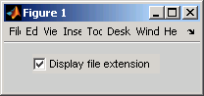

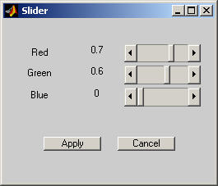

The interface should also include a figure with the image that is refreshed after changing the effects or by clicking the “refresh” button. The same goes for the second figure, which should display the histogram of the image.

Model the following effects in Python:

1. Adjust (rotation for X degrees) [-25°,25°]. Bear in mind that after rotation, the image should be stretched and cropped to fit the original image width and height.
2. Brightness
3. Contrast
4. Warmth
5. Saturation
6. Fade
7. Highlights
8. Shadows
9. Vignette
10. Tilt shift (radial and linear, both positioned in the centre of the image)
11. Sharpen
12. Zoom in [1x,10x]

The effects can be seen in Instagram -> upload -> edit, or any other image processing software.